Tools and Techniques Lab Report
Bitcoin Price Prediction using Machine Learning

Submitted by
Jyotika Suman (1828164)
Shalini Basak (1828192)
Shruti Mukherjee (1828203)
Trisita Datta(1828215)

Of

School of Computer Engineering

To

B.Tech Program in Computer Science and System Engineering
Kalinga Institute of Industrial Technology, Deemed to be University
Bhubaneswar, India

March, 2021

Project Guide: Divya Kumari
Abstract:-

Bitcoin is that the first digital decentralized cryptocurrency that has shown a big increase in market capitalisation in recent years. the target of this paper is to work out the predictable price direction of Bitcoin by Machine Learning Techniques.

The goal of this paper is to determine with what accuracy the direction of Bitcoin price are often predicted.The task is achieved with varying degrees of success through the implementation of a Bayesian optimized Recurrent neural network (RNN) , an extended Short Term Memory (LSTM) and Support Vector Machine (SVM) network. The LSTM achieves the very best classification accuracy of 52% and a RMSE of 8%. the favored ARIMA model for statistic forecasting is implemented as a comparison to the deep learning models. needless to say , the non-linear deep learning methods outperform the ARIMA forecast which performs poorly. Hence, both deep learning models are marked on GPU and CPU with the training time of the GPU exceeding the CPU implementation by 67.7%.

Keywords :-

Recurrent Neural Network(RNN), Long Short Term Memory(LSTM), Support Vector Machine(SVM), ARIMA (Auto-regressive Integrated Moving Average)

Introduction:

Bitcoin:

Bitcoin may be a digital currency that was created in January 2009. It follows the ideas began during a whitepaper by the mysterious and pseudonymous Satoshi Nakamoto.1 The identity of the person or persons who created the technology remains a mystery. It offers lower transaction fees as compared to the other traditional online payment mechanisms and it is operated by a decentralized authority, unlike government-issued currencies.

Bitcoin may be a sort of cryptocurrency. There are not any physical bitcoins, only balances kept on a public ledger that everybody has transparent access to. All bitcoin transactions are verified by a huge amount of computing power. Bitcoins are not issued by the banks or government. Individual bitcoins are not as valuable as a commodity. Despite it not being tender, Bitcoin is extremely popular and has triggered the launch of many other cryptocurrencies, collectively mentioned as alt-coins. Bitcoin is usually abbreviated as "BTC." Investment are often done through various marketplaces referred to as “bitcoin exchanges”. These allow people to sell or buy Bitcoins via different currencies. the most important Bitcoin exchange is Mt Gox. Bitcoins are stored during a digital wallet which is essentially sort of a virtual checking account . The record of all the transactions, the timestamp data is stored during a place called Blockchain. Each record during a blockchain is named a block. Each block contains a pointer to a previous block of knowledge . the info on blockchain is encrypted. During transactions the user’s name isn't revealed, but only their wallet ID is formed public.

Prediction:

The Bitcoin’s value varies a bit like a stock albeit differently. There are variety of algorithms used on stock exchange data for price prediction. However, the parameters affecting Bitcoin are different. Therefore it's necessary to predict the worth of Bitcoin in order that correct investment decisions are often made. the worth of Bitcoin doesn't depend upon the business events or intervening government unlike stock exchange . Thus, to predict the worth we feel it's necessary to leverage machine learning technology to predict the worth of Bitcoin.

In our project, we used a statistic model and deep learning to leverage machine learning technology to predict the real-time price of Bitcoin. However, machine learning literature is lacking verification of whether or not the stock evaluation strategies are legitimate for the cryptocurrencies, and if so, how they'll be modified. that's what features want to be eliminated or introduced as a foundation for price prediction, whether current machine learning algorithms work for cryptocurrencies, and which technique yields the superb outcomes. during this paper, we inspect these questions. Such evaluation is applicable given a particularly good quantity of attention that cryptocurrencies, particularly Bitcoin, are generating. Each people and large financial corporations are drawn to cryptocurrencies thanks to the transparency and anonymity that they provide to their users, additionally to their resistance to fraud due to the dispersed nature of the ledger statistics. Moreover, purchasing cryptocurrencies are promising in terms of creating income, and need to be of interest to buyers. additionally , to familiarizing themselves with industry tendencies and political and financial information, they will utilize machine learning models to make a decision whether to shop for or promote cryptocurrency.

Literature Review:-

Bitcoin is currently a replacement technology and therefore the world costliest cryptocurrency thus there are some price prediction models available. Amjad et al. make use of the historical statistic price data for forecasting the price and inter-changing methodology and Garcia et al. also displayed that the increments in opinion polarization and trade volume antecede the rising of Bitcoin price. Chen and Lazer determined investment methodologies by observing and classifying the twitter feeds. Go et al. train the classifiers by with the help of the dataset collected by distant supervision and approve the classification performance. Go et al. ask the powerful paper by Pang et al. where those analysts have set a typical for machine-learning based opinion analysis. Their approach is credited together of the first attempts at applying machine learning strategies

to the difficulty of opinion analysis. Some recent works focused on high-frequency trading and applying deep-learning techniques like RNN for the prediction on statistic data that are tested dense, feed-forward networks as function model. McNally predicts the Bitcoin pricing process using machine learning techniques, like recurrent neural networks (RNNs) and long STM (LSTM) and compare results with those obtained using autoregressive integrated moving average (ARIMA) models. From a comparison between multi-layer perceptron MLP and non-linear autoregressive exogenous (NARX) model is formed . They conclude that MLP also can be used for stock exchange prediction albeit it doesn't outperform the NARX model in price prediction. The authors made use of MATLAB’s neural network toolbox to create and evaluate the performance of the network. Another paper deals with daily statistic data 10-minute and 10-second time-interval data. they need created three time-series data sets for 30 60 and 120 minutes followed by performing GLM/random forest on the datasets which produce three linear models. These three models are linearly combined to predict the worth of bitcoin. consistent with the author is analyzing what has been done to predict the U.S. stock exchange . the conclusion of his work is that the mean square error of the prediction network was as large because the variance of the surplus return. In rather than directly forecasting the longer term price of the stock the authors predict the trend of the stock. The trend are often considered as a pattern. They perform both short-term predictions day or week predictions and also long-term predictions months they found that the latter produced better results with 79% accuracy. Another interesting approach the paper reflects is that the performance evaluation criteria of the network. supported the anticipated output the performance evaluation algorithm decides to either buy and sell or hold the stock. during this paper, we explored a number of the relevant methods of bitcoin sentiment prediction using tweets and Reddit posts and our approach is parametric and stems from a hypothetical modeling system supported stationarity and mixing.

Problem Statements :-

1.Bitcoin is that the most complex cryptocurrency which value change in every second.
2.Investing money for Bitcoin is more risk and fewer profit. 1.5.

Project Objectives :-

1.To predict bitcoin price with maximum efficiency using LSTM, RNN and SVM.

2. to match between SVM, RNN, ARIMA and LSTM to seek out which is that the best efficient algorithm for predicting bitcoin price.

3.To ensure less risk and more profit for investors.

Project Scope :-

Today Bitcoin may be a secure transaction system that features a valuable impact on capital. they're awarded under a restriction during which customers offer their computer authority to register and listing trades with the bitcoins. the acquisition and sale of Bitcoins in several currencies is administered in an alternate workplace where "purchase" or "sell" requests are placed within the ordered e-book. "Buy" or "bid" offers to speak about the aim of buying certain Bitcoins measures at a couple of costs while "provide" or "ask" offers to speak about the expectation of providing certain Bitcoins measures at a particular cost. The change is ordered through the coordination of pricing requests from the arrangement of e-books to a legitimate exchange between customers and suppliers

Block Diagram of Bitcoin Price Prediction :-

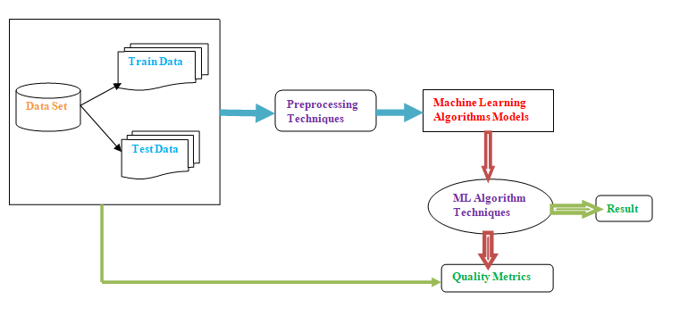

Methodology :

1.LSTM:-

The long STM network or LSTM addresses the common problem of disappearing gradients within the recurrent neural network. this is often a kind of recurrent neural network that's utilized in profound learning, as very large architectures are often trained. LSTM enables the network to find out more about many time steps by maintaining a more-steady error. this permits the network to find out long-term trust. LSTM cell contains forget and remember gates that allow the cell to make a decision which information to dam or transmit supported its strength and importance [9]. As a result, weak signals that prevent the gradient from disappearing are often blocked. The performance of the RNN and LSTM network is assessed to work out the model's efficiency. Elman's recent development of recurrent neural networks has gained popularity in network designs and increased computational power from graphical processing units. they're primarily useful with sequential data (in our case Bitcoins statistic data) because each neuron or unit can access its internal memory to stay information about the previous input. Fig 2 shows simple RNN Structure [14]. One limitation of RNN is that it's influenced by the disappearing problem of the gradient. This problem is that since the layers and time steps of the network are interrelated, they're vulnerable to exploding or disappearing gradients.

RNN structure:-

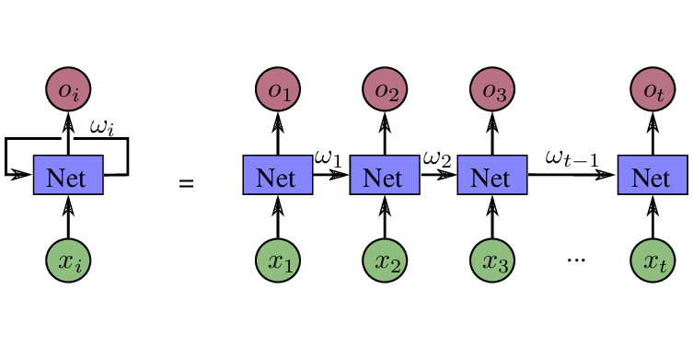

Vanishing gradients are a drag because they will convince be insufficient to find out for the system, while inclinations are often restricted by regularization. additionally , some examinations have found that while RNN is in a position to affect long-term dependencies, they often fail to find out in practice thanks to difficulties between gradient succession and long-term dependency.
ARIMA:-

The basic principle of the ARIMA model is to estimate the trend and therefore the seasonality of the series and to get rid of them from the series so as to get a stationary series. during this series, statistical forecasting techniques are often used. the ultimate step would be to convert the forecast values to the first scale by applying constraints on trend and seasonality. Trend – mean varying over time. for instance , during this case, we saw a mean increase within the number of bitcoin price over time. Seasonality – time-frame variations. for instance , people may tend to shop for cars during a given month thanks to pay increments or festivals. Static forecasts are performed and therefore the RMSE is calculated to match with LSTM model results. ARIMA model is implemented to match its predictability with the LSTM and find out which is that the best suited method for statistic data which has huge fluctuations. ARIMA (Auto regression integrated moving average) may be a class model that captures a set of various standard temporal structures in statistic data which include trend, seasonality, cycles, errors and nonstationary data. this enables it to exhibit dynamic temporal behavioral a time sequence. the info preparation phase is completed almost like the LSTM model approach.

SVM:-

Support Vector Machine is machine learning technique which is essentially used for classification. it's a kernel based classifier; it had been developed for linear separation which was ready to classify data into two classes only. SVM has been used for various realistic problems like face, gesture recognition , cancer diagnosis voice identification and glaucoma diagnosis.

RNN:-

Recurrent neural networks (RNN) are the state of the art algorithm for sequential data and are employed by Apple's Siri and and Google's voice search. it is the primary algorithm that remembers its input, because of an inside memory, which makes it perfectly fitted to machine learning problems that involve sequential data. it's one of the algorithms behind the scenes of the amazing achievements seen in deep learning over the past few years. during this post, we'll cover the essential concepts of how recurrent neural networks work, what the foremost important issues are and therefore the thanks to unravel them.

Data Collection & Prepossessing:

In this section, we've a dataset that's bitstamp USD_1-min_data_2012-01-01_to_2021-03-31 for data collection and prepossessing. This dataset was collected using API services from the dedicated server and allowing uninterrupted continuously real-time data.

For the first phase of this paper, we've collected Bitcoin values from four different databases: Coinmarketcap, Bitstamp, Coinbase, and Blockchain Info. We gathered Bitcoin historical and realtime price data using their publicly available API. From Coinmarketcap and Blockchain Info, we've collected 11 key features (see Table 1) relevant to the Bitcoin values for our research with their real-time feature (e.g. created date). additionally , from Bitstamp database, we also acquired 10 more transaction-based different level of details which are returned by API involve the pricing data (see Table 2). This data-set was gathered on an interval of 1-minute and it continued the data collection process. From Coinbase API we collected bitcoin real-time data so on predict the fluctuation of the bitcoin price with others collected data-set. We collected bitcoin price data by building an automatic web scraper which is real-time data pulled from Coinbase API over the course of weeks or months or years relying on program continuation. of those key features are connected with bitcoin network and important to real-time observation of moving prices.

Data Prepossessing:-

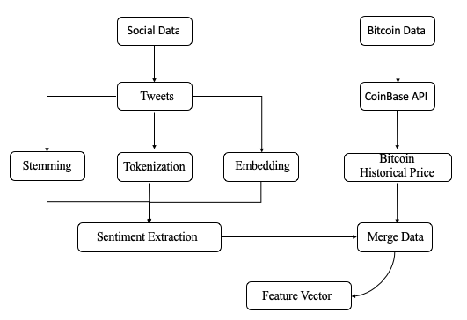

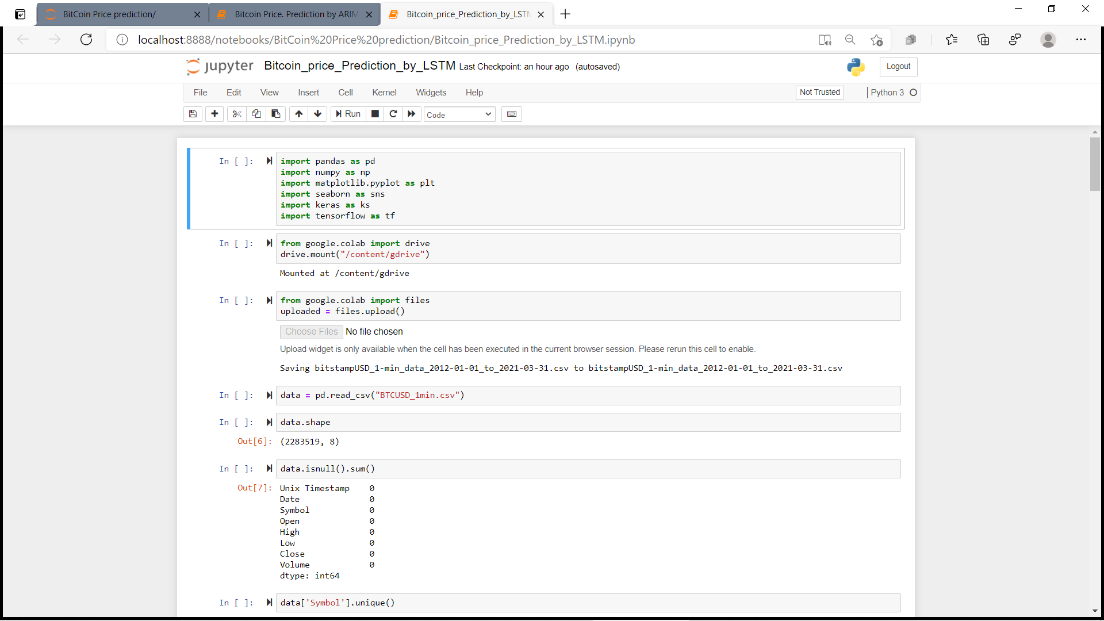
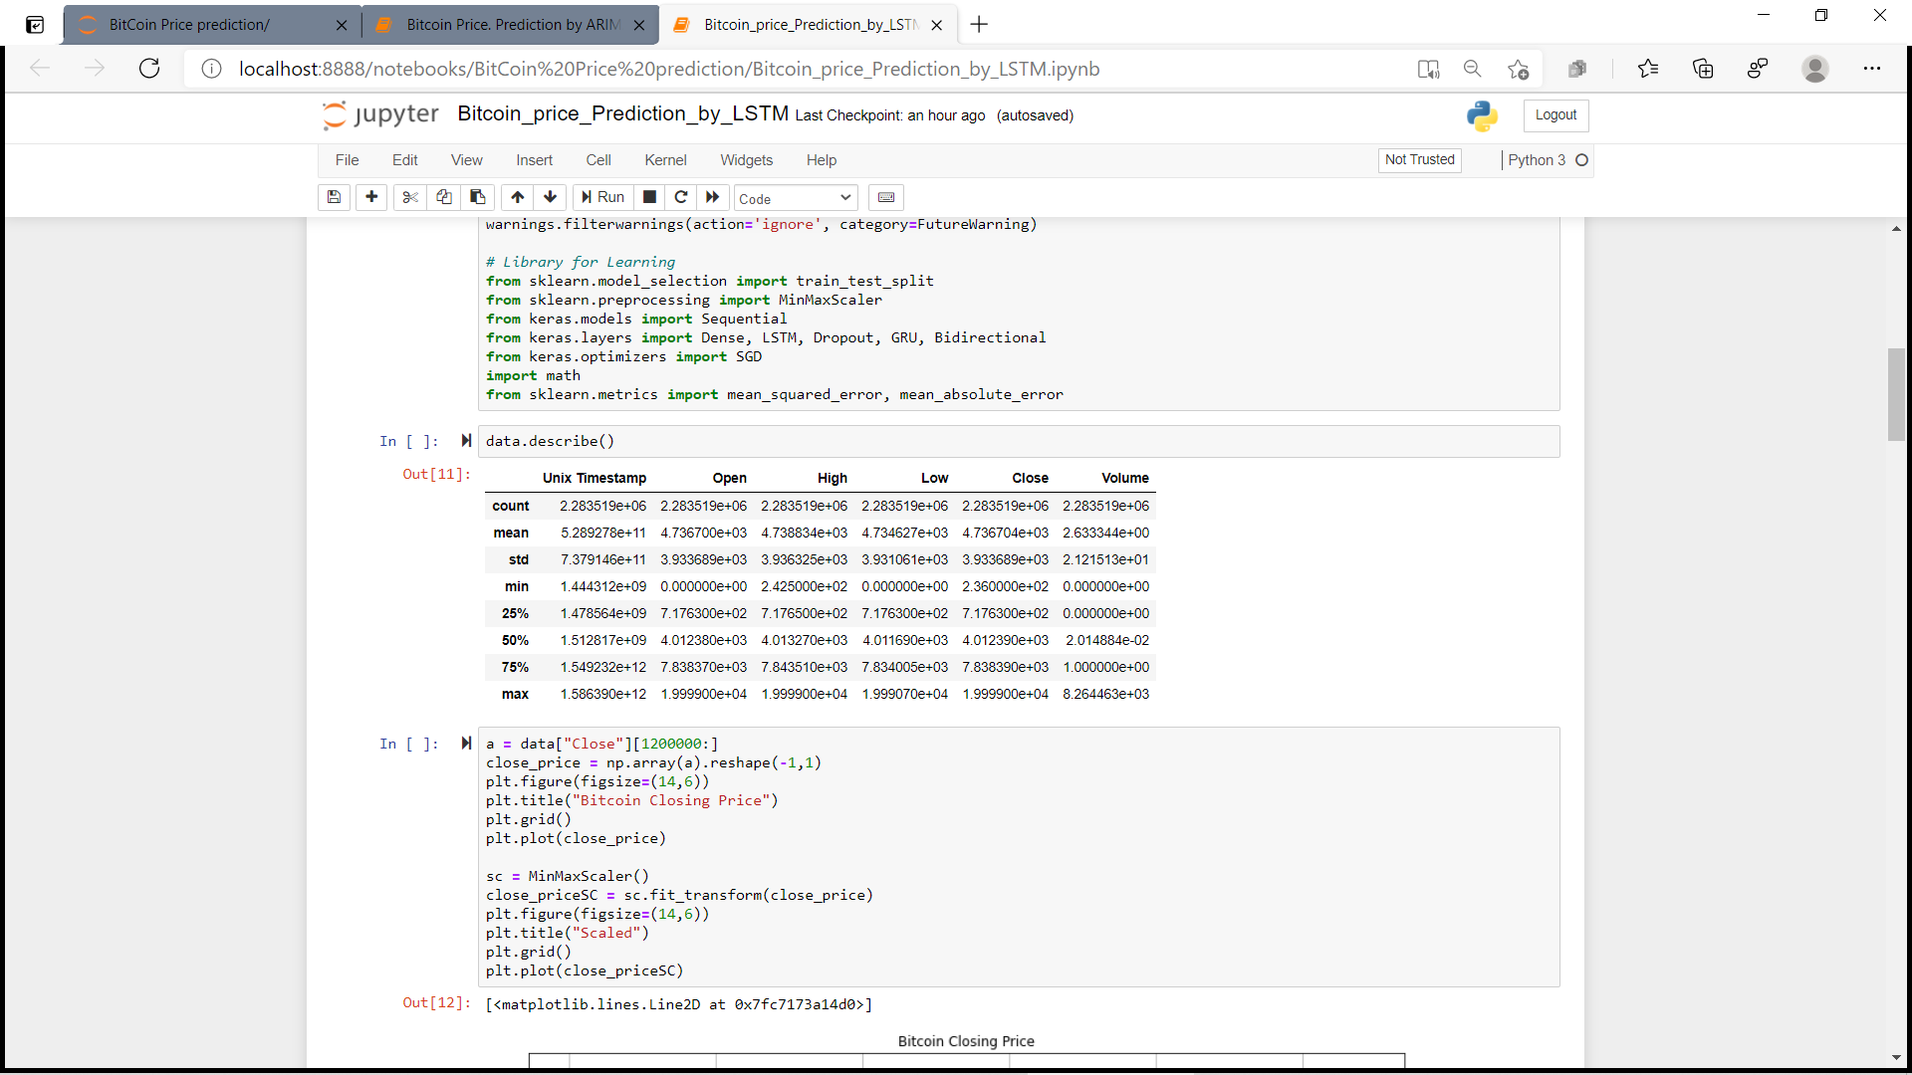

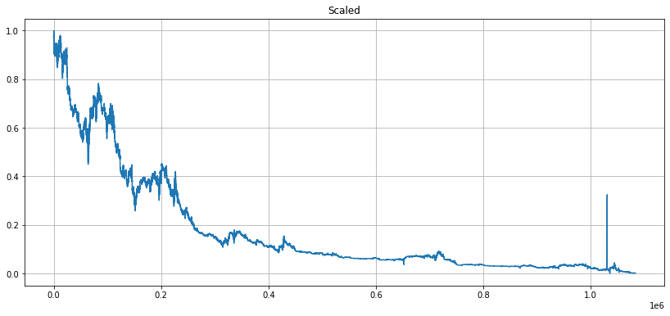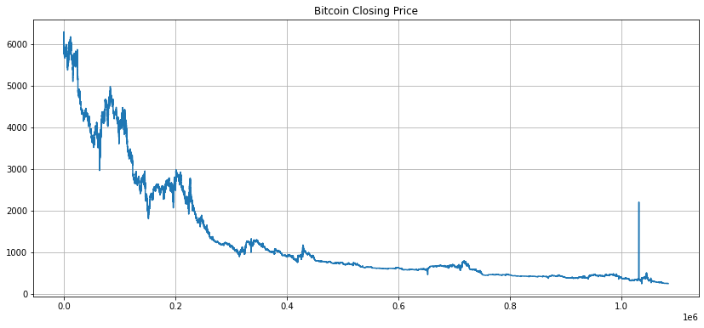

Data Exploration of ARIMA:

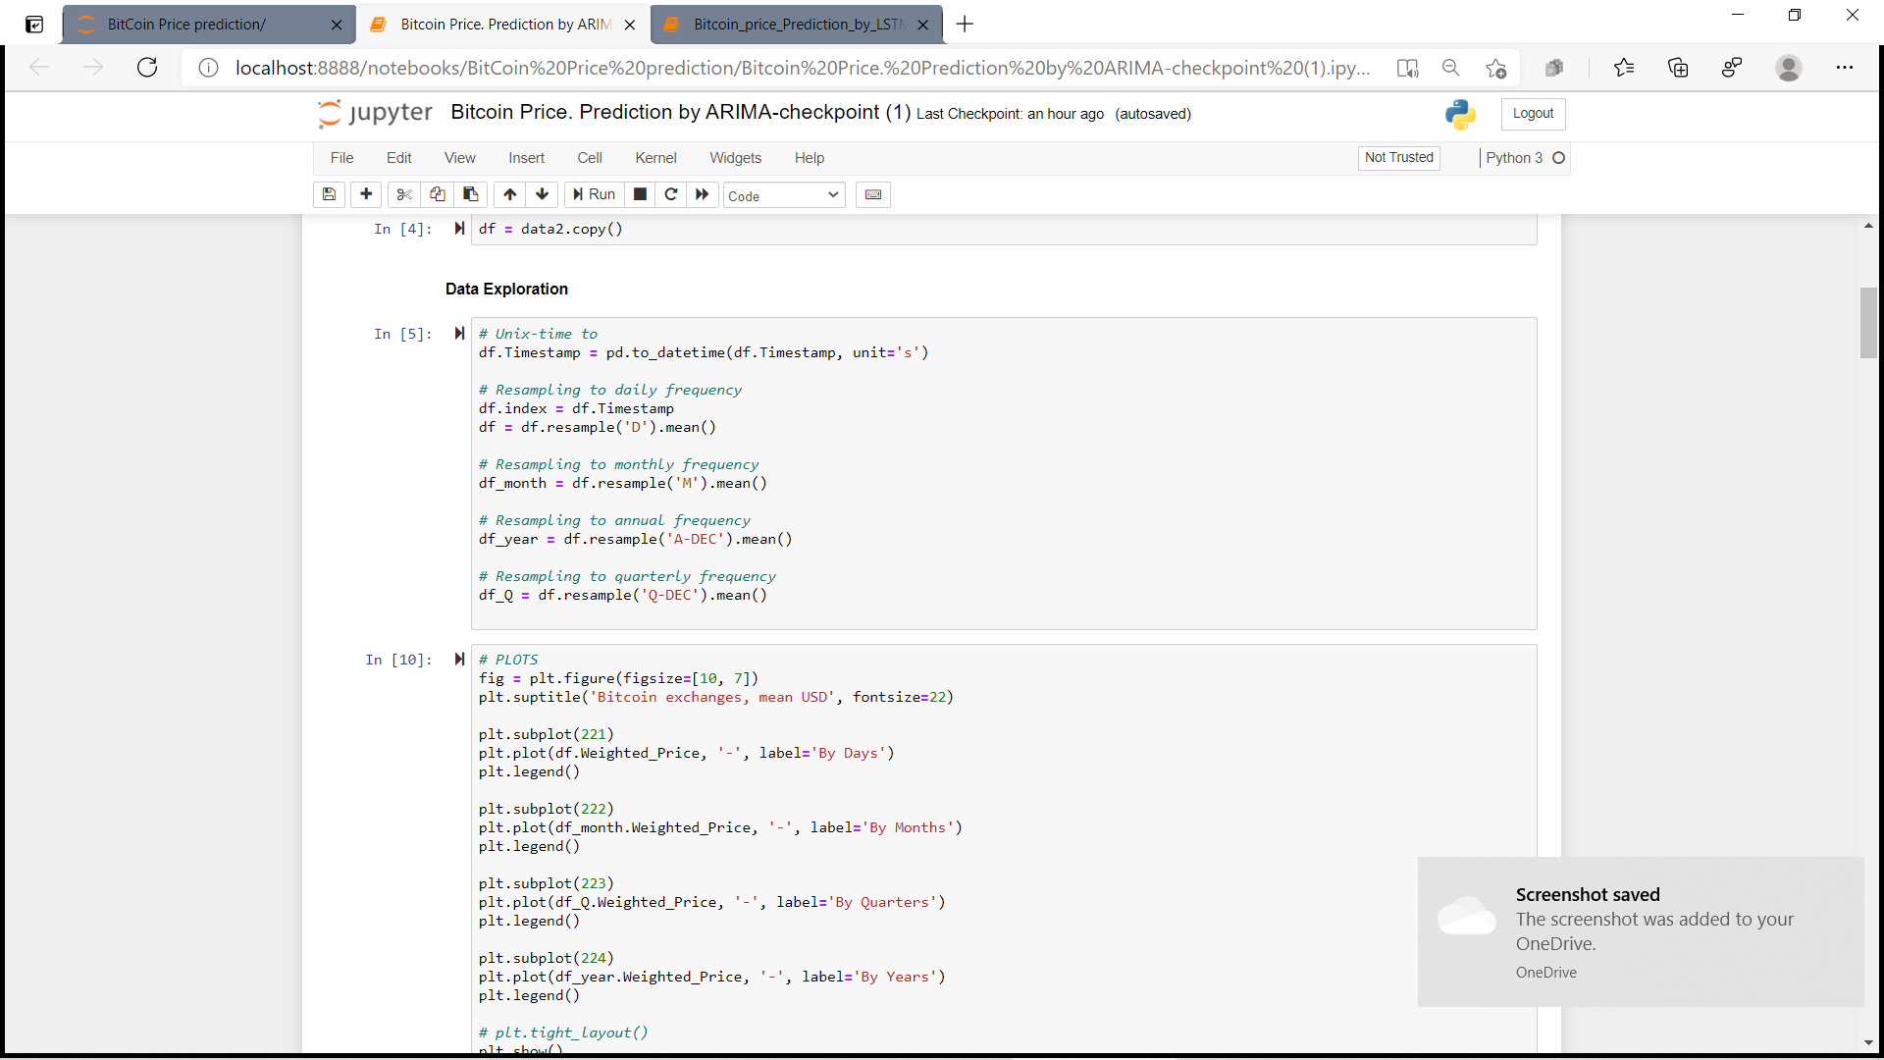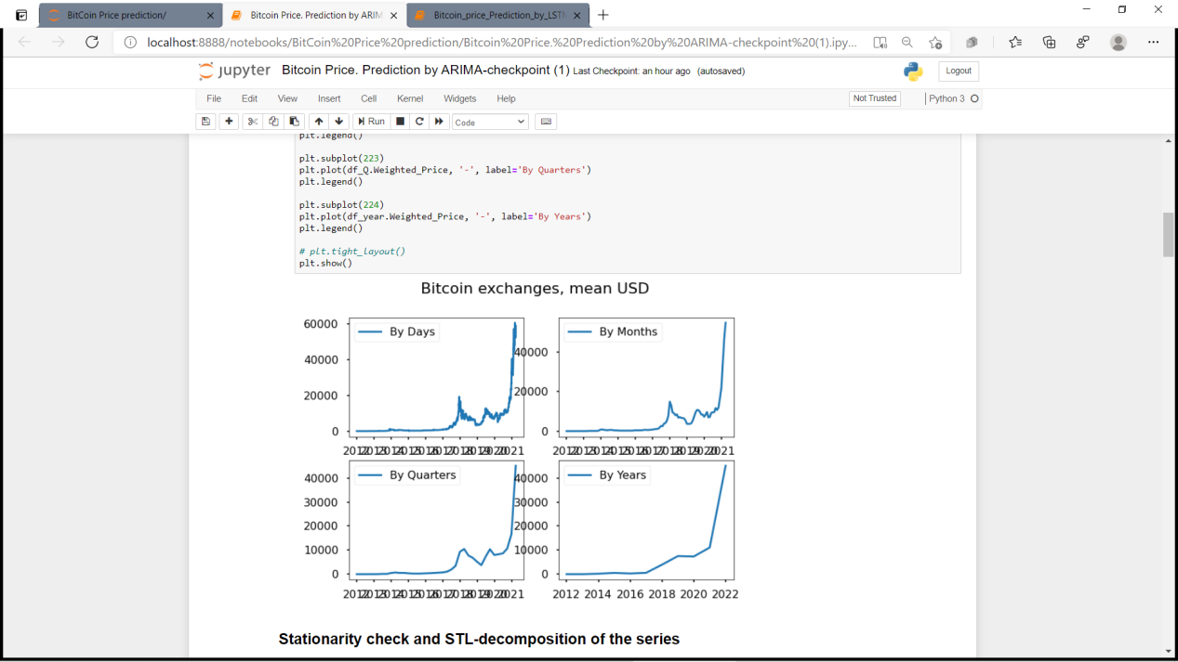

Stationarity check and STL-decomposition of the series:-

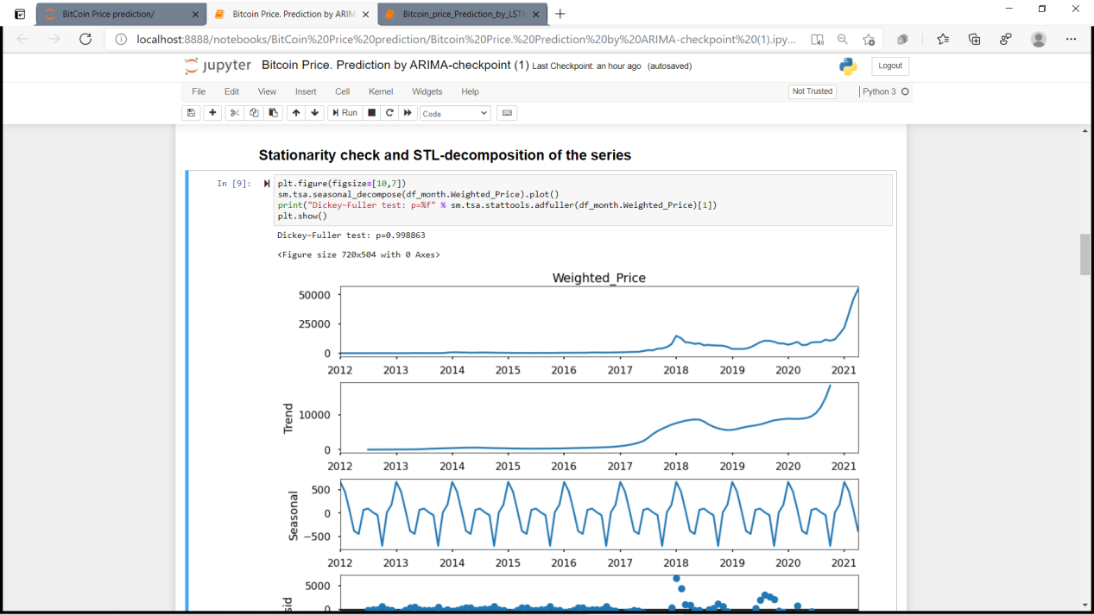

Model Selection: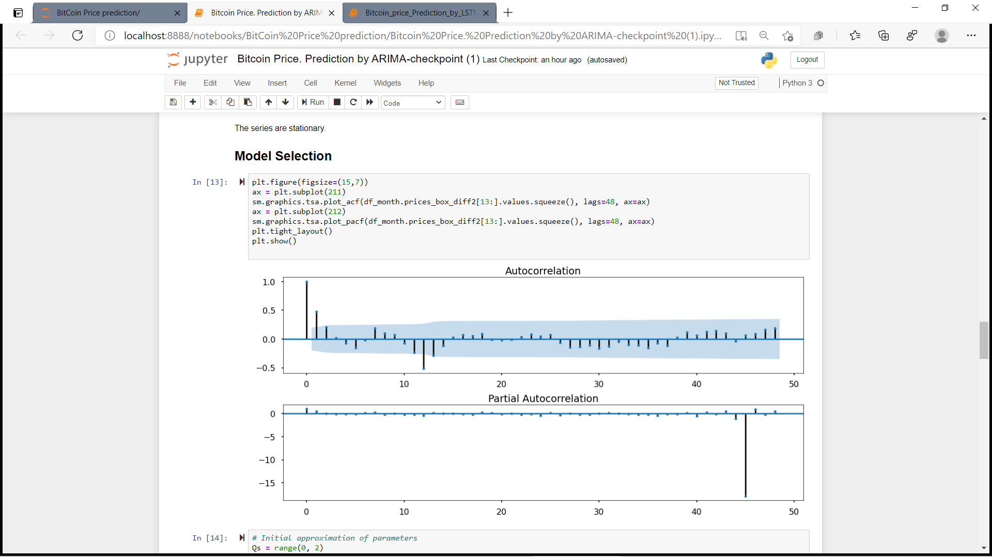
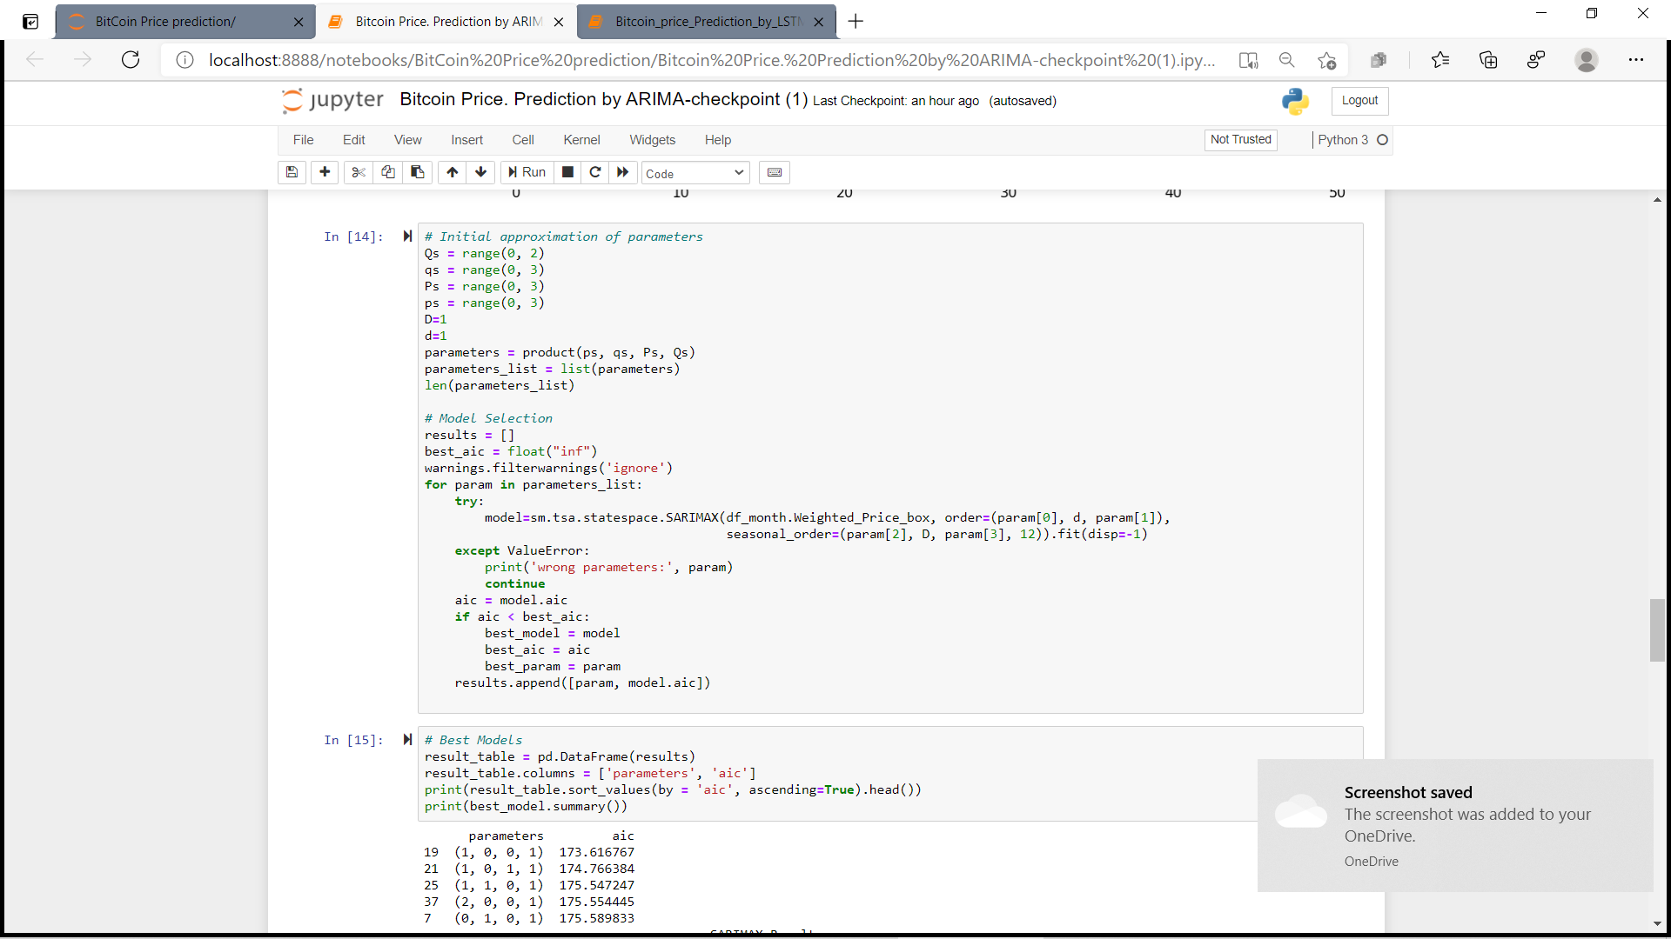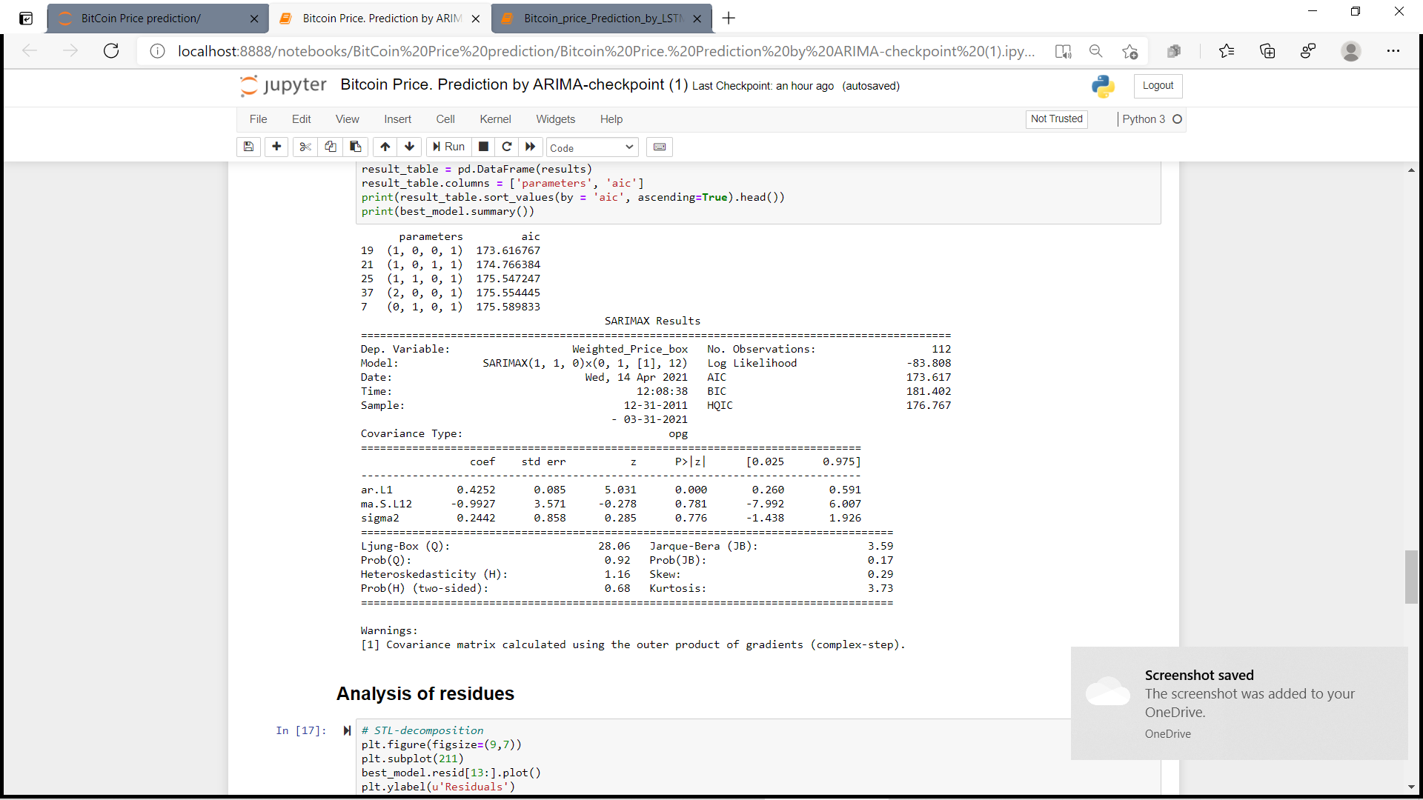

Analysis of residues:

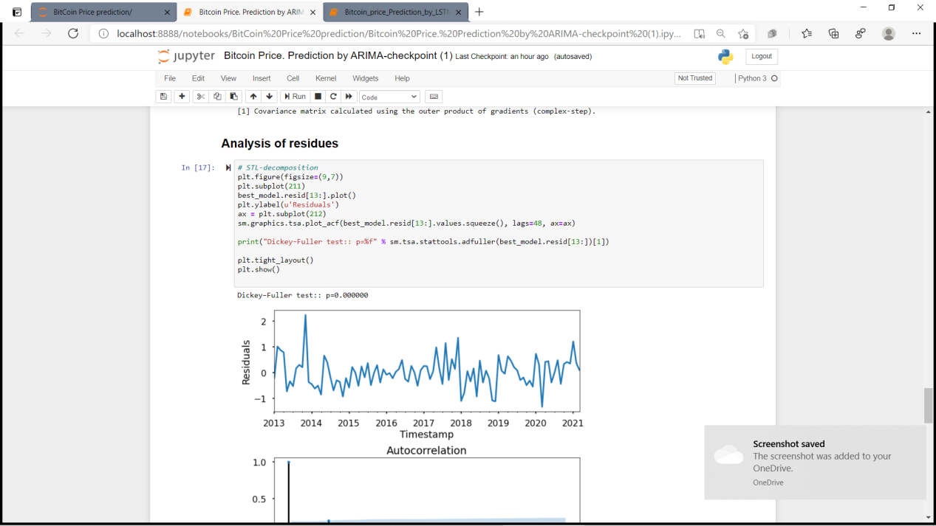
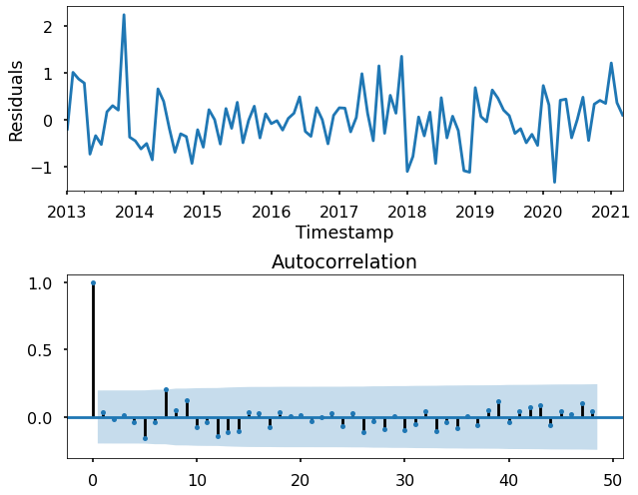

Data Prediction using ARIMA:-

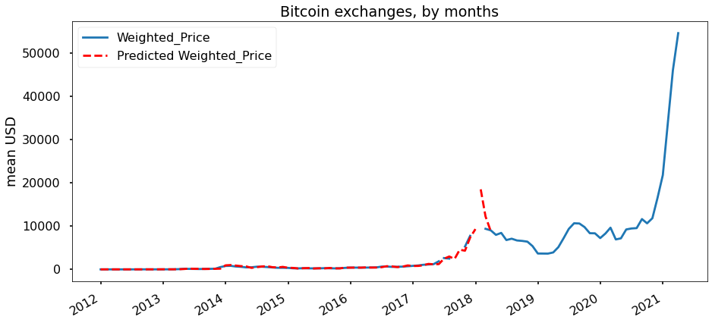
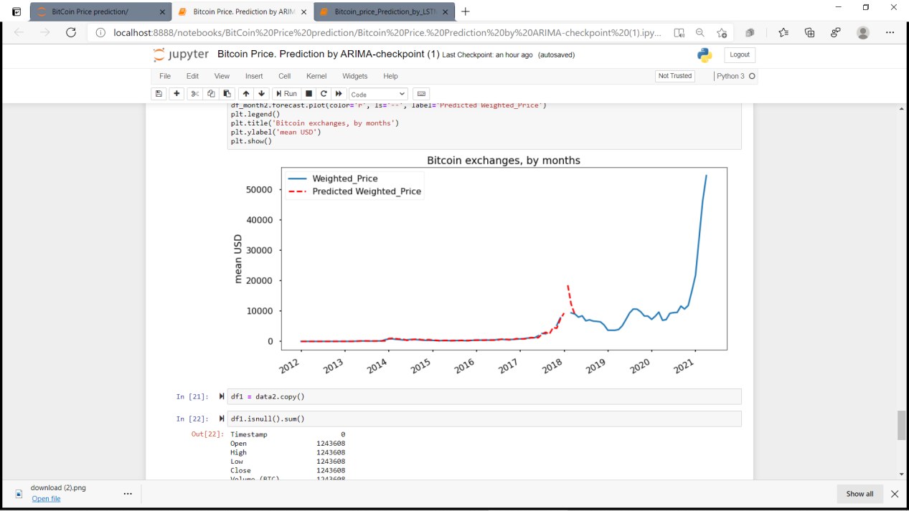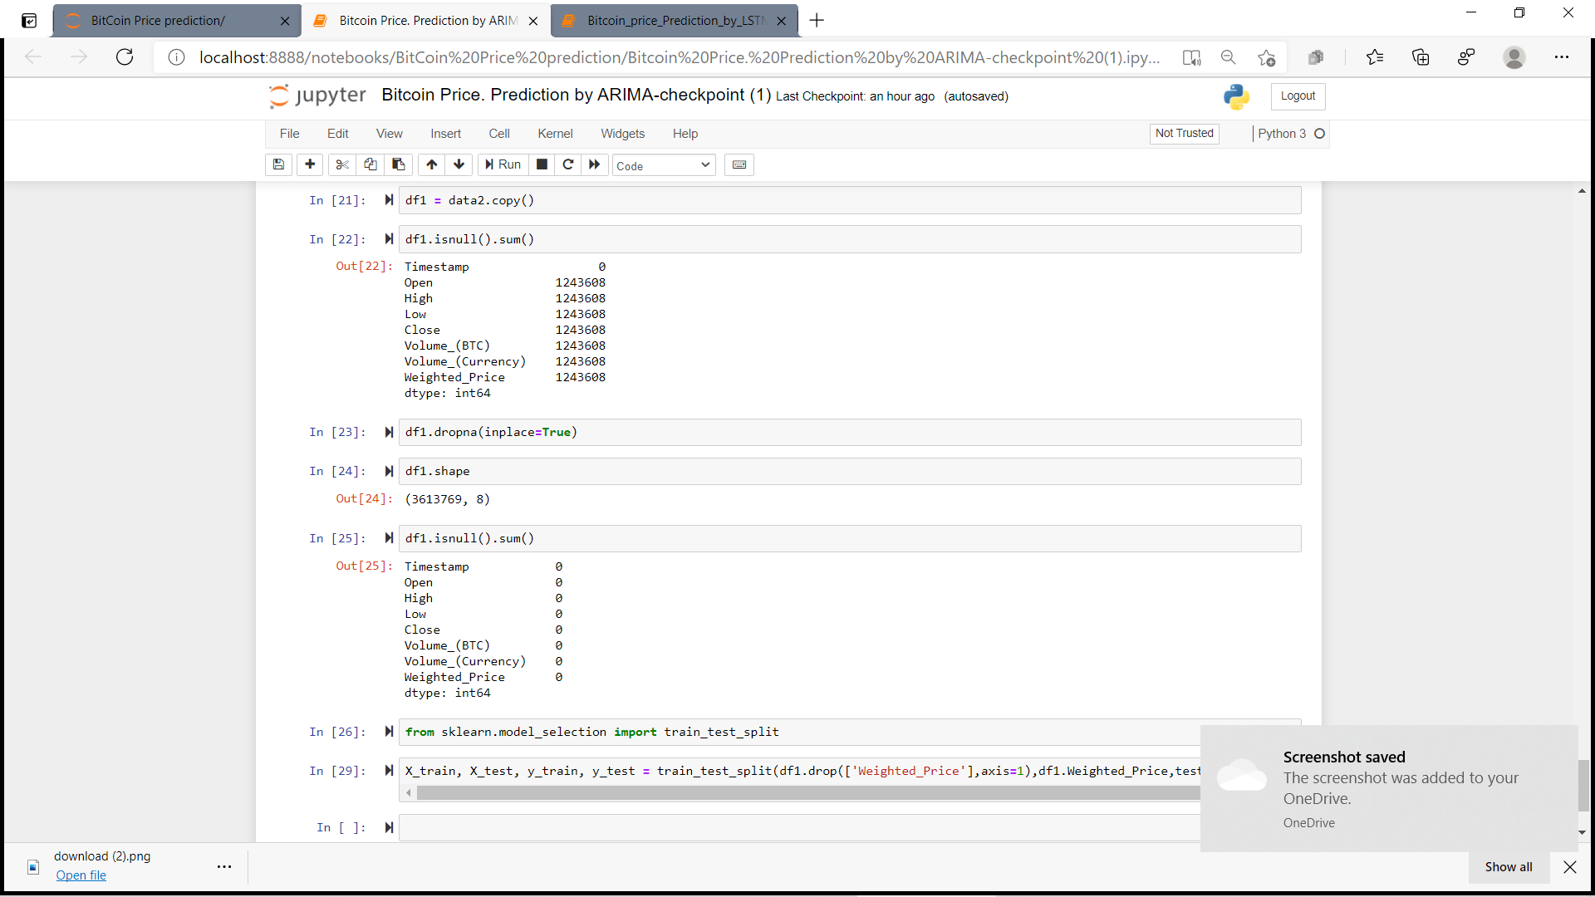

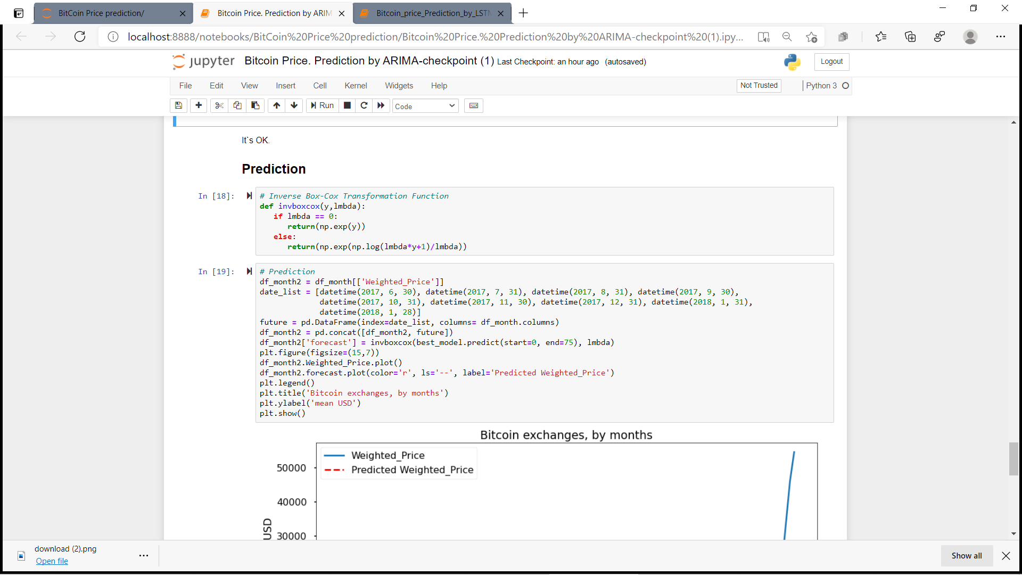

Train Test Split Using LSTM:
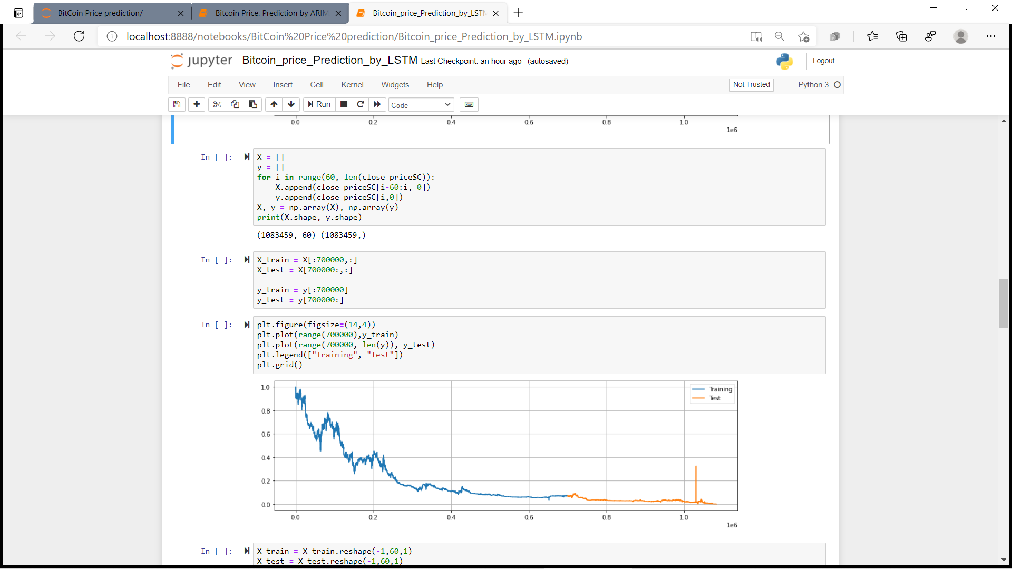
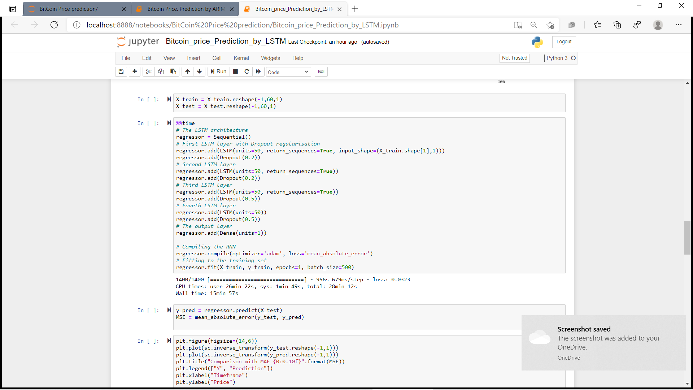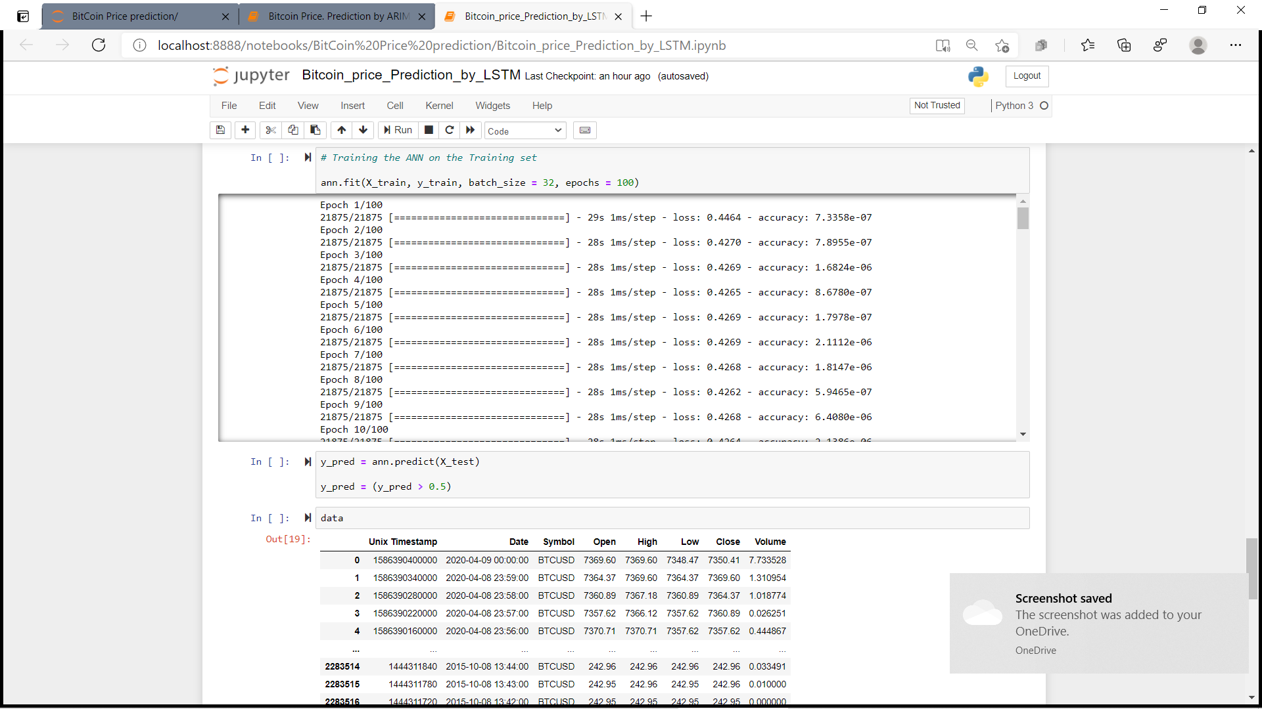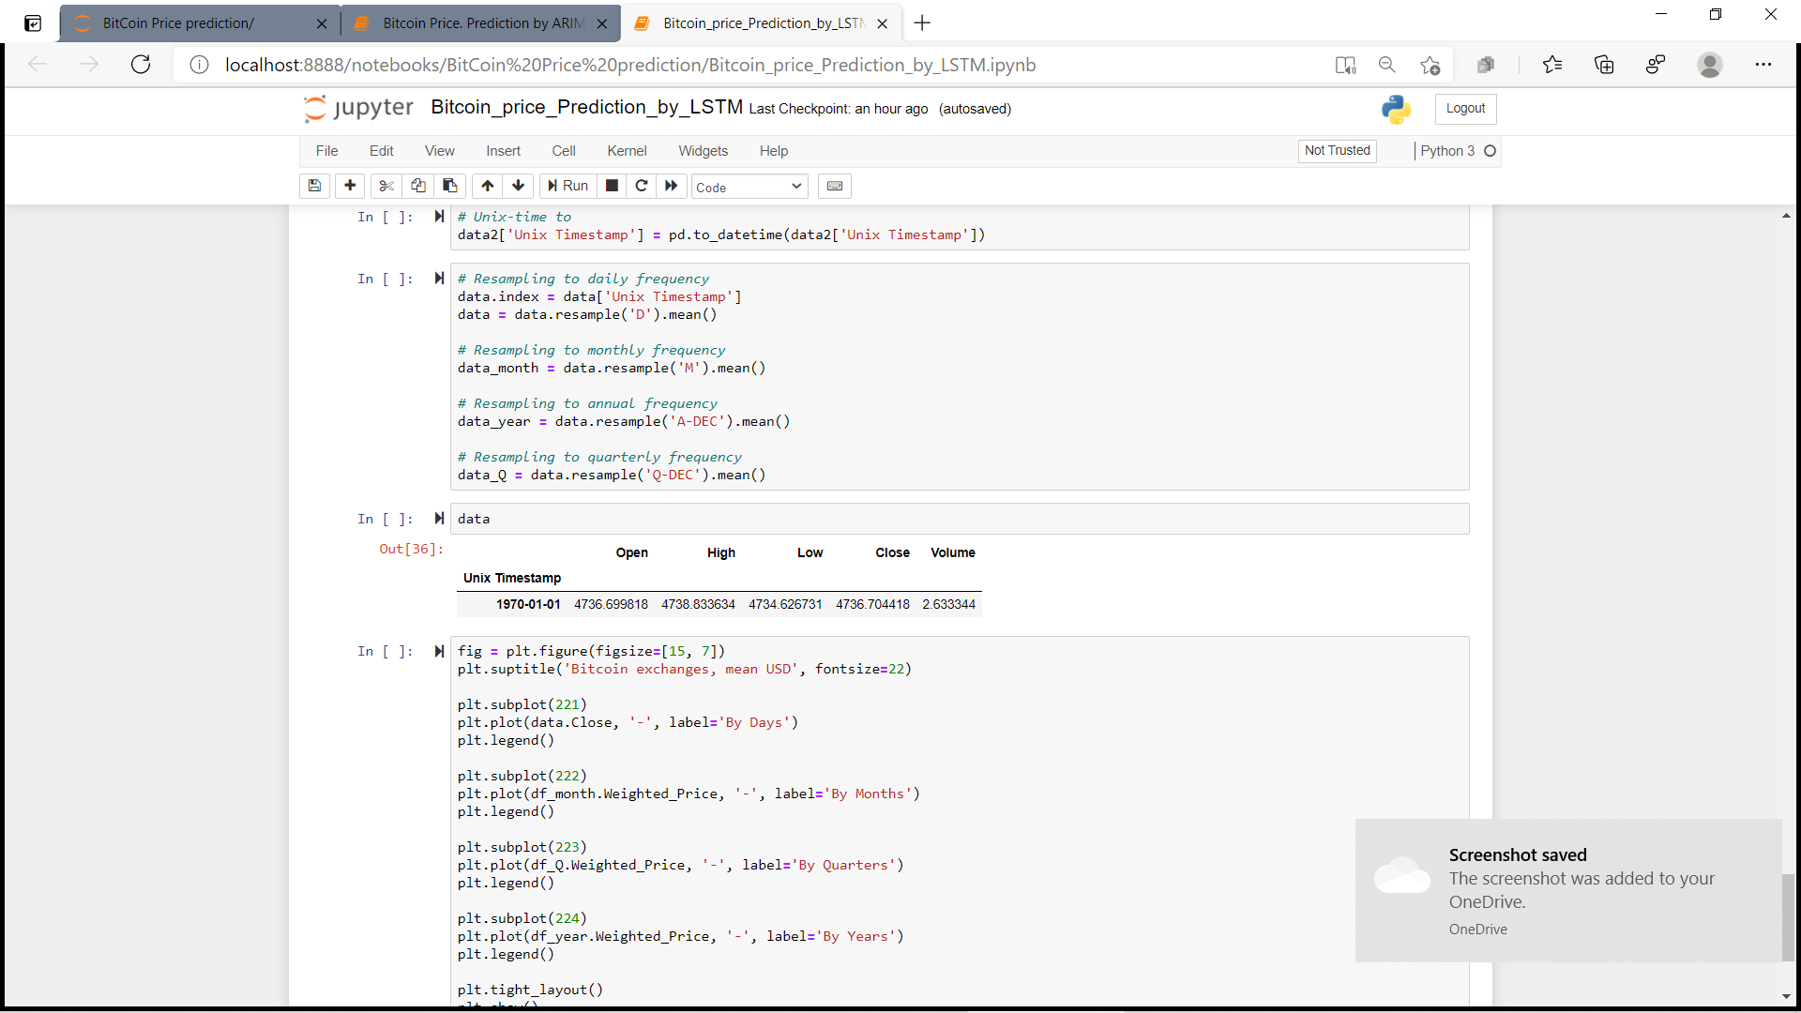

Support Vector Machine Regression:-

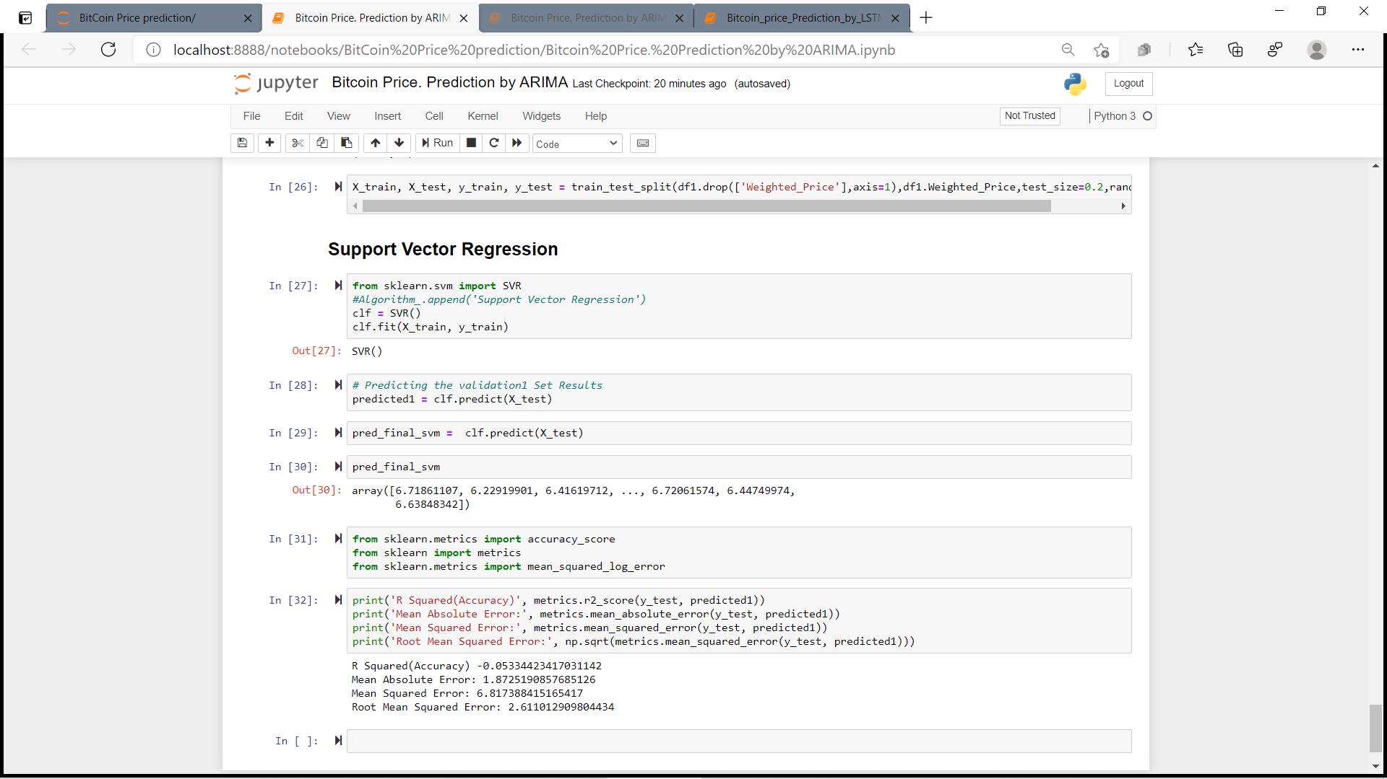

Conclusion and Future Works:-

This study focuses on the Bitcoin price and sentiments of this marketplace for the event of the predictive model. It does also calculate the market sentiments to predict the price more accurately. The prediction is restricted to previous data. the facility to predict data streaming would improve the model's performance and predictability. The model developed using LSTM is more accurate than the traditional models that demonstrate a deep learning model. In our case, LSTM (Long Short-Term Memory) is clearly an efficient learner on training data than ARIMA, with the LSTM more capable of recognizing long-term dependencies. This study uses the daily price fluctuations of the Bitcoin to further investigate the model's predictability with hourly price fluctuations within the longer term . This paper consists of comparing ARIMA with LSTM. The result would be confirmed by comparing more machine learning models within the longer term . during this work, we've only considered Twitter and Reddit posts data to research people's feelings which can be biased because not all folks that trade stocks share their views on Twitter and Reddit. Moreover, Facebook posts and LinkedIn data are often included during a comprehensive collection of public opinion . additionally , this sentiments are often combined with the prediction of the LSTM model to influence the selection of an autonomous trading assistant to buy for or sell Bitcoins.

List of Abbreviations:-

USD — us Dollar; RNN — Recurrent Neural Network; ARIMA — Autoregressive Integrated Moving Average; LSTM — Long STM , MSE — Mean-Square Error; RMSE — Root-Mean-Square Error; SA — Sentiment Analysis; DCI — Digital Currency Initiative; NARX — Non-linear Autoregressive Exogenous; MLP — Multi-layer Perceptron; GLM — Generalized Linear Model; API — Application Programming Interface; BTC — Bitcoin.

Contribution:-

Jyotika Suman(1828164)- RNN
Shalini Basak-(1828192) LSTM
Shruti Mukherjee(1828203)-ARIMA
Trisita Datta(1828215)-SVM
REPORT CONTRIBUTION-ALL

References:

- A Research On Bitcoin Price Prediction Using
Machine Learning Algorithms Lekkala Sreekanth Reddy, Dr.P. Sriramya
INTERNATIONAL JOURNAL OF SCIENTIFIC & TECHNOLOGY RESEARCH VOLUME 9, ISSUE 04, APRIL 2020

- Bitcoin Price Prediction using Machine Learning‖ ,Siddhi Velankar*, Sakshi Valecha*, Shreya Maji* *Department of Electronics & Telecommunication, Pune Institute of Computer Technology, Pune, Maharashtra,India409-415.

- M. Daniela and A. BUTOI, ―Data mining on Romanian stock market using neural networks for price prediction‖. Informatica Economica, 17,2013.

4.Real-Time Prediction of BITCOIN Price using Machine Learning Techniques and Public Sentiment Analysis S M Rajua,∗ , Ali Mohammad Tarifb
a,bComputer Science, International Islamic University Malaysia, Gombak, Malaysia

5.D.L.K. Chuen, Handbook of Digital Currency: Bitcoin, Innovation, Financial Instruments, and Big Data, Academic Press, 2015.
- https://blog.eduonix.com/artificial-intelligence/predicting-bitcoin-price-using-machine-learning/
- https://www.sciencedirect.com/science/article/abs/pii/S037704271930398X
- https://arxiv.org/ftp/arxiv/papers/2006/2006.14473.pdf

